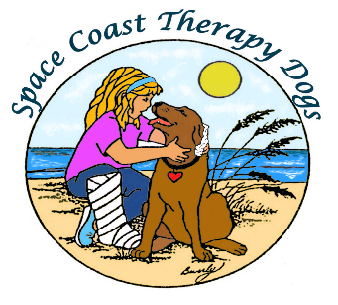

New Membership/Member Renewal Form

Please print clearly
Name of Handler ________________________________________Date ______________________
Name of Registered Dog(s) ____________________________________________________________
Breed or Mixes _____________________________________________________________________
Dog’s Birthday (MM/DD/YY) ___________________________________________________________
Address _____________________________________________________________________________
City ______________________________________________ State ___________ Zip Code ______________
E-Mail _______________________________________________________________________________
Home # ________________________Mobile # __________________________ Work ________________
Check one: New member ______ Membership Renewal _____ Supporting Member _____
Please consider supporting some of these activities:
- Attending community events (i.e., Poocharella, Paws in the Park)
- Coordinating special SCTD events
- Cocoa/Rockledge Christmas Parade
- Photos for our website and Facebook page
- Public relations: sharing our mission
- Read-to-a-dog library programs

Renewing Members Only
Annual Volunteer Hours - January 1 through December 31 (Total = Driving Time + Visit Time)

Dog #1 Hours
Dog #3 Hours

Dog #2 Hours
Dog #4 Hours

Total Hours

SIGNATURE _DATE

Before Mailing: 1) Sign and date this form. By signing, you grant permission to allow your image and your dog’s to be used in publications, news releases, social media, and in other communications promoting SCTD’s mission.
2) Enclose your dues ($20 Single-$10 Supporting), payable to “SCTD.”
3) Enclose copies of your ATD membership card and ATD Renewal Health Verification Form.

Mail to: Space Coast Therapy Dogs, Inc.
P.O. Box 561326
Rockledge, FL 32956-1326

